
International Journal of Medical, Healthcare and Life Sciences
ISSN: xxxx-xxxx
Link

Article Title

First Name Last Name ¹, First Name Last Name ^{2*}

¹ Title, Department, Institution, City, Country
² Title, Department, Institution, City, Country

* Corresponding Author: 1234@gmail.com

Citation: A. Author surname. “Title here”. International Journal of Medical, Healthcare and Life Sciences, vol, No, pp.xxx–xxx. Year. https://doi.org/0000000000/0000

Received: xx Mon year
Accepted: xx Mon year

Abstract
The abstract should clearly summarize the main purpose of the study, the research problem, the method or approach used, the key findings, and the main contribution of the research. It should briefly explain what was done in the study, how the study was conducted, what results were obtained, and why the findings are important. Authors should avoid citations, undefined abbreviations, and unnecessary background details in the abstract. The abstract must be written in Times New Roman, font size 9, and the text must be justified. The abstract should be between 150 and 250 words. Abstracts shorter than 150 words or longer than 250 words may be returned for revision.

Keywords: Keyword One, Two, Three, Four, Five

INTRODUCTION

Authors should insert their manuscript text in the designated sections of this template. The body text must be formatted in Times New Roman, 11-point font size, black font color, and Justified content.
Each paragraph should begin with a first-line indentation of 2 characters (2ch). To ensure consistency in manuscript formatting, authors are strongly encouraged to prepare their paper directly in this template or copy and paste their content into the appropriate sections while preserving the required formatting style.

LITERATURE REVIEW

Authors should insert their manuscript text in the designated sections of this template. The body text must be formatted in Times New Roman, 11-point font size, black font color, and Justified content.
Each paragraph should begin with a first-line indentation of 2 characters (2ch). To ensure consistency in manuscript formatting, authors are strongly encouraged to prepare their paper directly in this template or copy and paste their content into the appropriate sections while preserving the required formatting style.
Authors should insert their manuscript text in the designated sections of this template. The body text must be formatted in Times New Roman, 11-point font size, black font color, and Justified content.
Second Level Headings
Authors should insert their manuscript text in the designated sections of this template. The body text must be formatted in Times New Roman, 11-point font size, black font color, and Justified content.
Each paragraph should begin with a first-line indentation of 2 characters (2ch). To ensure consistency in manuscript formatting, authors are strongly encouraged to prepare their paper directly in this template or copy and paste their content into the appropriate sections while preserving the required formatting style.
Third Level Heading
Authors should insert their manuscript text in the designated sections of this template. The body text must be formatted in Times New Roman, 11-point font size, black font color, and Justified content.
Each paragraph should begin with a first-line indentation of 2 characters (2ch). To ensure consistency in manuscript formatting, authors are strongly encouraged to prepare their paper directly in this template or copy and paste their content into the appropriate sections while preserving the required formatting style.

METHODOLOGY

Criteria
Authors should insert their manuscript text in the designated sections of this template. The body text must be formatted in Times New Roman, 11-point font size, black font color, and Justified content.
Each paragraph should begin with a first-line indentation of 2 characters (2ch). To ensure consistency in manuscript formatting, authors are strongly encouraged to prepare their paper directly in this template or copy and paste their content into the appropriate sections while preserving the required formatting style.
The table must be referred in the main text like Table 1. The table caption must be centered aligned and the initials of the caption must be capital as shown in the example shown below.

Table 1. Descriptive Statistics of the Articles
Text | Text/No | Text/No | Text/No
Text | Text | Text | Text
Text | Text | Text | Text
Text | Text | Text | Text
Text | Text | Text | Text

RESULTS

Authors should insert their manuscript text in the designated sections of this template. The body text must be formatted in Times New Roman, 11-point font size, black font color, and Justified content.
Each paragraph should begin with a first-line indentation of 2 characters (2ch). To ensure consistency in manuscript formatting, authors are strongly encouraged to prepare their paper directly in this template or copy and paste their content into the appropriate sections while preserving the required formatting style.
The Figure must be referred to in the main text like Fig.1 or Figure 1 (But follow one consistent style for figures referred to in the main text). The figure caption must be centered aligned and the initials of the caption must be capitalized as shown in the example shown below.
The Figure must be referred in the main text like Fig.1 or Figure 1 (But follow one consistent style for figures referred to in the main text). One figure must be referred as Fig.1 or Figure 1. But for more than one figure, it can be referred to as Figs 1 and 2, or Figures 1 and 2. The figure caption must be centered aligned, and the initials of the caption must be capitalized as shown in the example shown below, Fig.1.
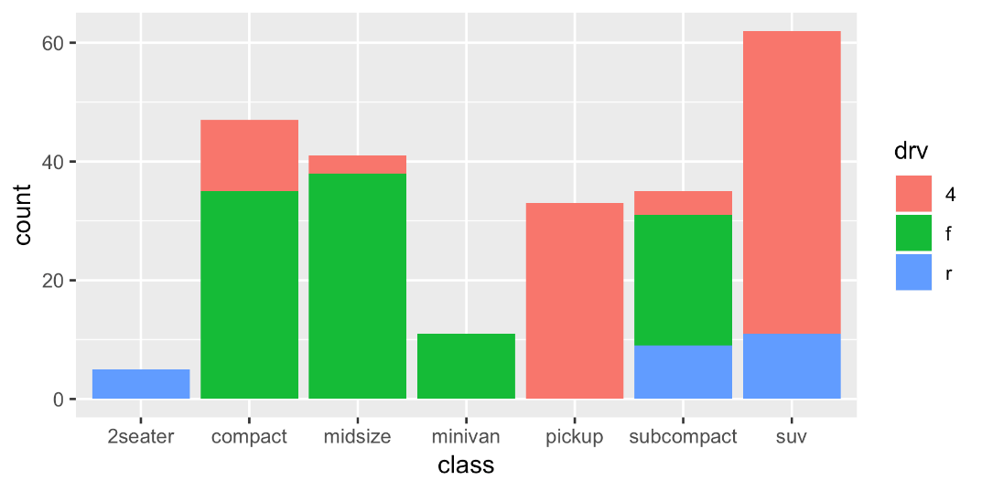
Figure 1. Bar Chart

DISCUSSION

Authors should insert their manuscript text in the designated sections of this template. The body text must be formatted in Times New Roman, 11-point font size, black font color, and Justified content.
Each paragraph should begin with a first-line indentation of 2 characters (2ch). To ensure consistency in manuscript formatting, authors are strongly encouraged to prepare their paper directly in this template or copy and paste their content into the appropriate sections while preserving the required formatting style.
References Style and Format
The manuscript must follow the IEEE referencing style. In-text citations must be numbered in square brackets, such as [1], [2], and [3]. Citation numbers should appear in the order in which the sources are first cited in the main text.
All references listed at the end of the manuscript must be cited in the main text. Similarly, every in-text citation must have a matching entry in the reference list. Authors must ensure that citation numbering is properly sequenced and consistent throughout the manuscript according to IEEE style.
Example of In-Text Citation
Recent studies have highlighted the importance of artificial intelligence in engineering systems [1]. Computational modelling has also been widely used to improve simulation accuracy and decision-making processes [2]. In addition, sustainable technology has become an important area of research in modern engineering and scientific development [3].
For the end list style and format, please check the reference list at the end.

CONCLUSION

Authors should insert their manuscript text in the designated sections of this template. The body text must be formatted in Times New Roman, 11-point font size, black font color, and Justified content.
Each paragraph should begin with a first-line indentation of 2 characters (2ch). To ensure consistency in manuscript formatting, authors are strongly encouraged to prepare their paper directly in this template or copy and paste their content into the appropriate sections while preserving the required formatting style.

REFERENCES
[1] J. Smith and R. Ahmed, “Artificial intelligence applications in modern engineering systems,” IEEE Access, vol. 11, pp. 24560–24572, 2023.
[2] S. Russell and P. Norvig, Artificial Intelligence: A Modern Approach, 4th ed. Hoboken, NJ, USA: Pearson, 2021.
[3] M. Brown, “Digital transformation and innovation management,” in Handbook of Technology and Innovation Management, A. Green and L. White, Eds. London, U.K.: Routledge, 2022, pp. 115–132.
[4] L. Chen, M. Patel, and K. Brown, “Computational modelling and simulation methods for engineering optimization,” in Proc. IEEE Int. Conf. Comput. Sci. Eng. (CSE), New York, NY, USA, 2023, pp. 88–94.
[5] World Health Organization, “Digital health,” World Health Organization. Accessed: May 22, 2026. [Online]. Available: https://www.who.int/health-topics/digital-health
[6] IEEE Standards Association, IEEE Standard for Software and System Test Documentation, IEEE Std 829-2008, 2008.

Note: The above references are provided only as formatting examples. Authors must replace them with the actual sources cited in their manuscript. All references listed at the end of the manuscript must be cited in the main text in proper numerical order.

