
International Journal of Public Policy and Management Studies
ISSN: xxxx-xxxx
Link

Article Title

First Name Last Name ¹, First Name Last Name ^{2*}

¹ Title, Department, Institution, City, Country
² Title, Department, Institution, City, Country

* Corresponding Author: 1234@gmail.com

Citation: Author, N., (Year). Title here. International Journal of Public Policy and Management Studies, vol(n), xxx–xxx. https://doi.org/0000000000/0000

Received: xx Mon year
Accepted: xx Mon year

ABSTRACT
The abstract should clearly summarize the main purpose of the study, the research problem, the method or approach used, the key findings, and the main contribution of the research. It should briefly explain what was done in the study, how the study was conducted, what results were obtained, and why the findings are important. Authors should avoid citations, undefined abbreviations, and unnecessary background details in the abstract. The abstract must be written in Times New Roman, font size 9, and the text must be justified. The abstract should be between 150 and 250 words. Abstracts shorter than 150 words or longer than 250 words may be returned for revision.

Keywords: Keyword One, Two, Three, Four, Five

INTRODUCTION

Authors should insert their manuscript text in the designated sections of this template. The body text must be formatted in Times New Roman, 11-point font size, black font color, and Justified content.
Each paragraph should begin with a first-line indentation of 2 characters (2ch). To ensure consistency in manuscript formatting, authors are strongly encouraged to prepare their paper directly in this template or copy and paste their content into the appropriate sections while preserving the required formatting style.

LITERATURE REVIEW

Authors should insert their manuscript text in the designated sections of this template. The body text must be formatted in Times New Roman, 11-point font size, black font color, and Justified content.
Each paragraph should begin with a first-line indentation of 2 characters (2ch). To ensure consistency in manuscript formatting, authors are strongly encouraged to prepare their paper directly in this template or copy and paste their content into the appropriate sections while preserving the required formatting style.
Authors should insert their manuscript text in the designated sections of this template. The body text must be formatted in Times New Roman, 11-point font size, black font color, and Justified content.
Second Level Headings
Authors should insert their manuscript text in the designated sections of this template. The body text must be formatted in Times New Roman, 11-point font size, black font color, and Justified content.
Each paragraph should begin with a first-line indentation of 2 characters (2ch). To ensure consistency in manuscript formatting, authors are strongly encouraged to prepare their paper directly in this template or copy and paste their content into the appropriate sections while preserving the required formatting style.
Third Level Heading
Authors should insert their manuscript text in the designated sections of this template. The body text must be formatted in Times New Roman, 11-point font size, black font color, and Justified content.
Each paragraph should begin with a first-line indentation of 2 characters (2ch). To ensure consistency in manuscript formatting, authors are strongly encouraged to prepare their paper directly in this template or copy and paste their content into the appropriate sections while preserving the required formatting style.

METHODOLOGY

Criteria
Authors should insert their manuscript text in the designated sections of this template. The body text must be formatted in Times New Roman, 11-point font size, black font color, and Justified content.
Each paragraph should begin with a first-line indentation of 2 characters (2ch). To ensure consistency in manuscript formatting, authors are strongly encouraged to prepare their paper directly in this template or copy and paste their content into the appropriate sections while preserving the required formatting style.
The table must be referred in the main text like Table 1. The table caption must be centered aligned and the initials of the caption must be capital as shown in the example shown below.

Table 1. Descriptive Statistics of the Articles
Text | Text/No | Text/No | Text/No
Text | Text | Text | Text
Text | Text | Text | Text
Text | Text | Text | Text
Text | Text | Text | Text

RESULTS

Authors should insert their manuscript text in the designated sections of this template. The body text must be formatted in Times New Roman, 11-point font size, black font color, and Justified content.
Each paragraph should begin with a first-line indentation of 2 characters (2ch). To ensure consistency in manuscript formatting, authors are strongly encouraged to prepare their paper directly in this template or copy and paste their content into the appropriate sections while preserving the required formatting style.
The Figure must be referred in the main text like Fig.1 or Figure 1 (But follow one consistent style for figures to refer in the main text) The figure caption must be centered aligned and the initials of the caption must be capital as shown in the example shown below.
The Figure must be referred in the main text like Fig.1 or Figure 1 (But follow one consistent style for figures to refer in the main text). One figure must be referred as Fig.1 or Figure 1. But for more than one figure, it can be referred as Figs 1 and 2, or Figures 1 and 2. The figure caption must be centered aligned and the initials of the caption must be capital as shown in the example shown below Fig.1.
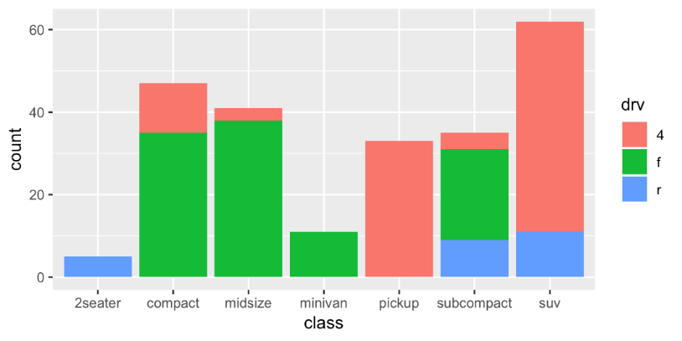
Figure 1. Bar Chart

DISCUSSION

Authors should insert their manuscript text in the designated sections of this template. The body text must be formatted in Times New Roman, 11-point font size, black font color, and Justified content.
Each paragraph should begin with a first-line indentation of 2 characters (2ch). To ensure consistency in manuscript formatting, authors are strongly encouraged to prepare their paper directly in this template or copy and paste their content into the appropriate sections while preserving the required formatting style.
References Style and Format
The manuscript must follow the APA 7th edition referencing style. In-text citations must follow the author–date format, such as (Smith & Ahmed, 2023) or Smith and Ahmed (2023). Citation numbers such as [1], [2], and [3] should not be used in APA style.
All references listed at the end of the manuscript must be cited in the main text. Similarly, every in-text citation must have a matching entry in the reference list. Authors must ensure that all citations and references are accurate, complete, and consistently formatted according to APA 7th edition guidelines.
References should be arranged in alphabetical order by the surname of the first author. The reference list should use a hanging indent format.
Example of In-Text Citation
Recent studies have highlighted the importance of artificial intelligence in engineering systems (Smith & Ahmed, 2023). Computational modelling has also been widely used to improve simulation accuracy and decision-making processes (Chen et al., 2023). In addition, sustainable technology has become an important area of research in modern engineering and scientific development (Williams & Kumar, 2024). Foundational concepts in artificial intelligence are also discussed by Russell and Norvig (2021), while organizational sources provide useful information on digital health and technology-related developments (World Health Organization, n.d.).
For the end list style and format, please check the reference list at the end

CONCLUSION

Authors should insert their manuscript text in the designated sections of this template. The body text must be formatted in Times New Roman, 11-point font size, black font color, and Justified content.
Each paragraph should begin with a first-line indentation of 2 characters (2ch). To ensure consistency in manuscript formatting, authors are strongly encouraged to prepare their paper directly in this template or copy and paste their content into the appropriate sections while preserving the required formatting style.

REFERENCES
Brown, M. (2022). Digital transformation and innovation management. In A. Green & L. White (Eds.), Handbook of technology and innovation management (pp. 115–132). Routledge.
Chen, L., Patel, M., & Brown, K. (2023). Computational modelling and simulation methods for engineering optimization. In Proceedings of the IEEE International Conference on Computational Science and Engineering (pp. 88–94). IEEE.
IEEE Standards Association. (2008). IEEE standard for software and system test documentation (IEEE Std 829-2008). IEEE.
Russell, S., & Norvig, P. (2021). Artificial intelligence: A modern approach (4th ed.). Pearson.
Smith, J., & Ahmed, R. (2023). Artificial intelligence applications in modern engineering systems. IEEE Access, 11, 24560–24572.
Williams, A., & Kumar, S. (2024). Sustainable technologies for future industrial development. Renewable and Sustainable Energy Reviews, 175, Article 113145.
World Health Organization. (n.d.). Digital health. Retrieved May 22, 2026, from https://www.who.int/health-topics/digital-health

Note: The above references are provided only as formatting examples. Authors must replace them with the actual sources cited in their manuscript. All sources listed in the reference list must be cited in the main text using APA 7th author–date citation style.

